**Allow Cookies Internet Explorer**

1. Run Internet Explorer. Click on IE Menu. Select **Internet Options**

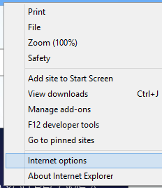

1. Privacy > Advanced

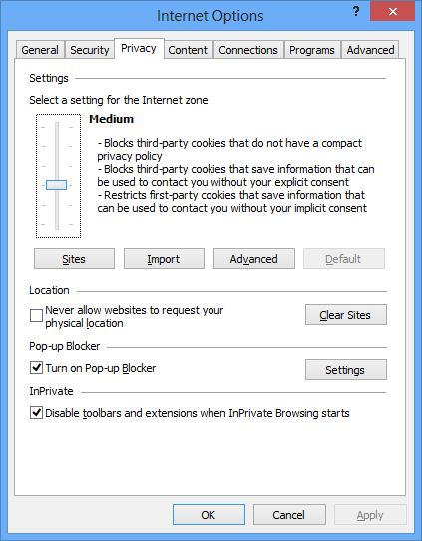

1. Accept Cookies as below.

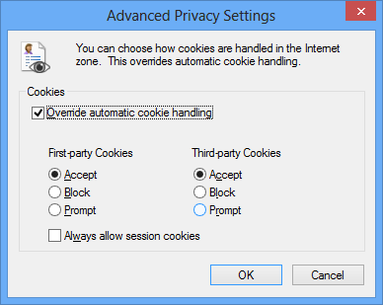

**DONE**

**Allow Cookies Chrome Browser**

1. Click on Chrome  **Menu> Settings**

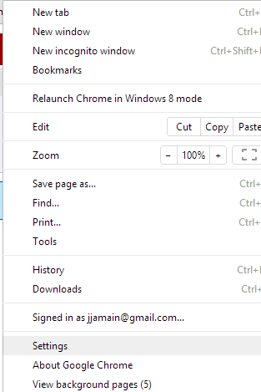

1. Click on Show advanced settings

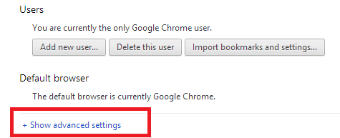

1. Click on **Content Settings**

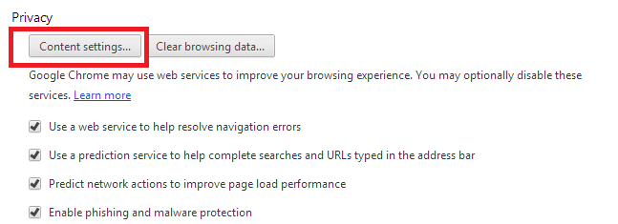

1. Select **Allow local data to be set**

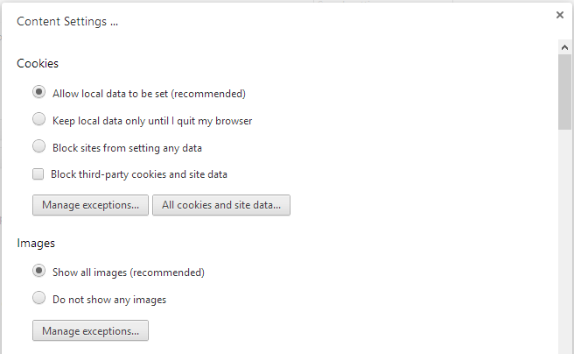

**DONE**

**Mozilla Firefox Allow Cookies**

**Note: Cookies are enabled by default in Firefox.**

To check or change your settings:

1. At the top of the Firefox window, click on the Firefox button and then select Options .
2. Select the Privacy panel.
3. Set **Firefox will:** to **Use custom settings for history**.

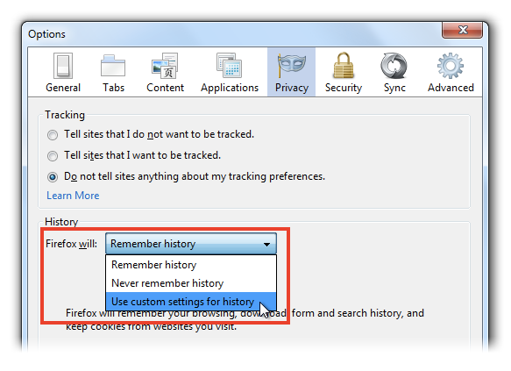

1. Check mark **Accept cookies from sites** to enable Cookies, and uncheck it to disable them.

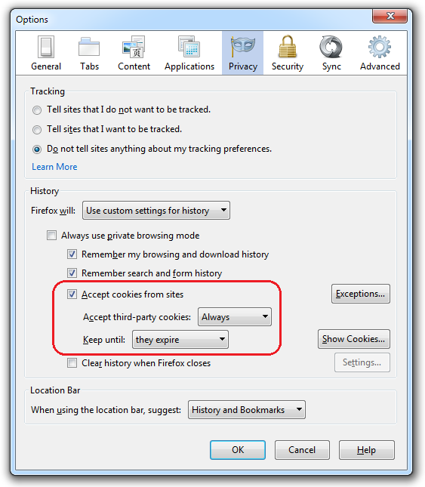

1. Click OK to close the Options window. **DONE**